**A.1**

**Table A.1.1 Sine wave values**

|  |  |
| --- | --- |
| **Amplitude (mV)** | **Frequency (KHz)** |
| 672.4 | 1.75 |
| 125.51 | 1.75 |
| 714.2 | 4.81 |
| 635.2 | 18.74 |

**Table A.1.2 Square Wave values**

|  |  |
| --- | --- |
| **Amplitude (mV)** | **Frequency (KHz)** |
| 510.19 | 2.05 |
| 431.94 | 3.93 |
| 281.7 | 6.04 |
| 137.72 | 7.86 |

**Table A.1.3 Triangular/Ramp Wave values**

|  |  |
| --- | --- |
| **Amplitude (mV)** | **Frequency (KHz)** |
| 568.75 | 2.07 |

**A.2**

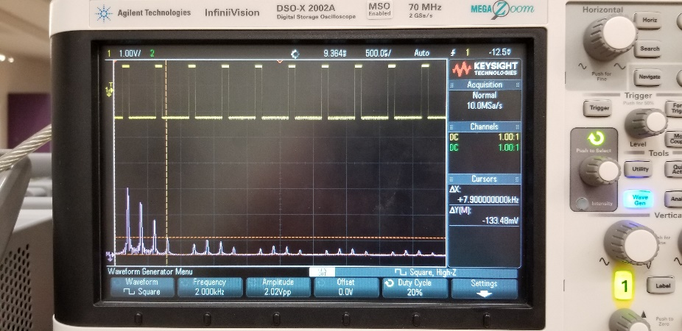

**Fig A.2.1 Spectrum for the Square wave at 20% duty cycle**

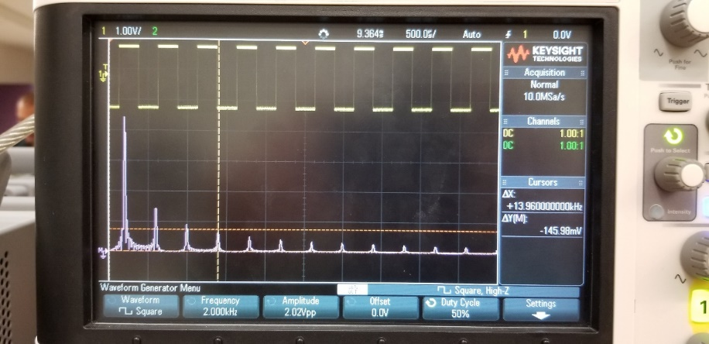

**Fig A.2.2 Spectrum for the Square wave at 50% duty cycle**

The spectral nulls and the separation between spectral components increase as the duty cycle in increased to 50% as is observed in Fig A.2.1 and Fig A.2.2 respectively. Since the fourier transform coefficient of a rect function is a sinc. The plots exhibit similar behavior with each decrementing harmonic and thus a change in the duty cycle leads to varying values for both amplitude and frequency.

**A.3**

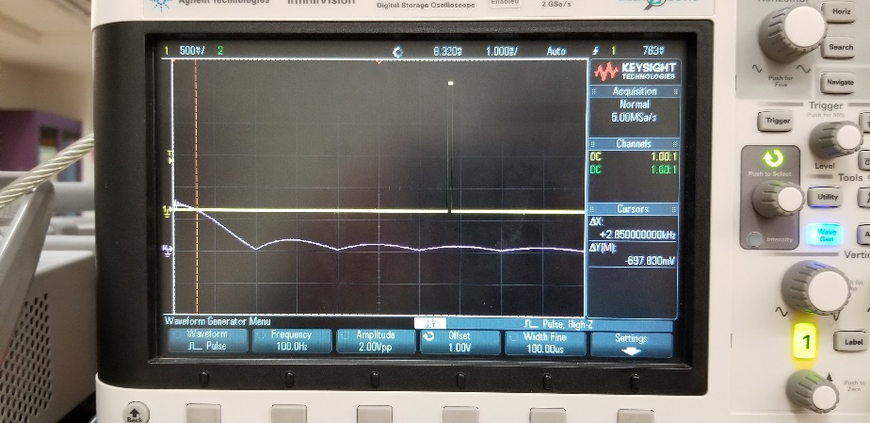

**Fig A.3.1 Spectrum for the Pulse wave**

The magnitude spectra Xw(f) as shown in Fig A.3.1 when compared with the magnitude spectra of xp(t), it is observed that the values remain consistent except for the value at the first harmonic. This is occurs due to the presence of DC component in the spectra.

**A.4**



**Fig A.4.1 Spectrum for the Square wave at 20% duty cycle**

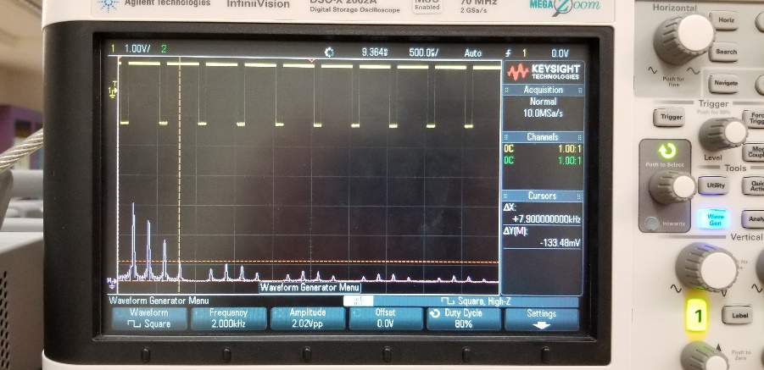

**Fig A.4.2 Spectrum for the Square wave at 80% duty cycle**

When the magnitude spectrum at 20% and 80% are compared, it is observed that both the plots remain consistent with each other in terms of the values recorded for amplitude and frequency. This can be attributed to the fact that both the plots are in fact inverse of each other.

**A.5**

When the spectrums of the sine, square and triangle wave are compared, it is observed that the first harmonic of each spectrum starts off with 2KHz. The sine graph can be represented in terms of 2 diracs, the square graph requires denser frequency values and finally the triangle wave could be better constructed with a few extra set of harmonics.

**B.1**

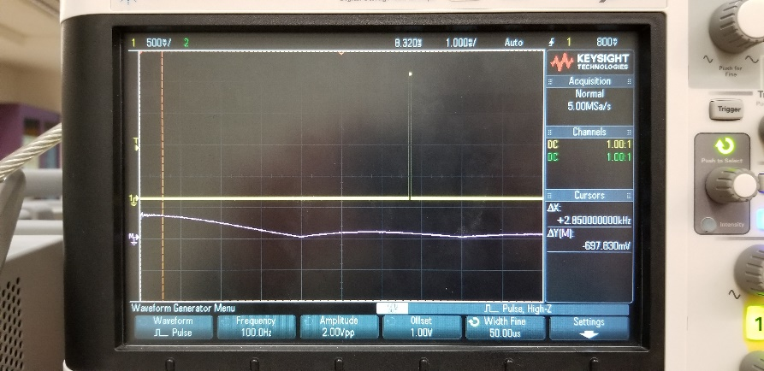

**Fig B.1.1 Spectrum for the Rectangular wave at T=50µs**

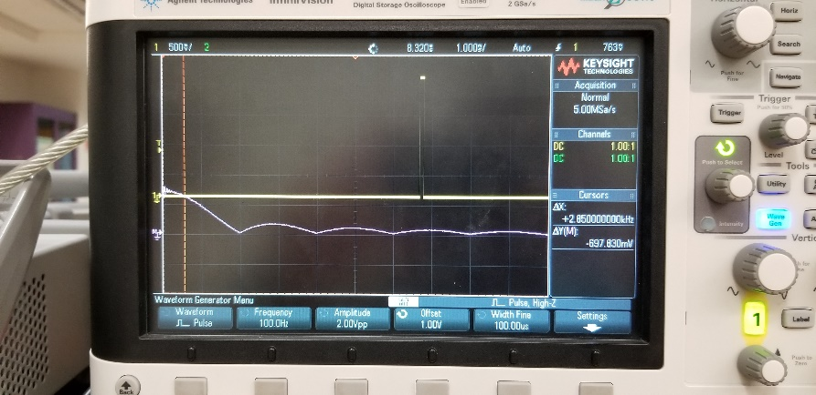

**Fig B.1.2 Spectrum for the Rectangular wave at T=100µs**

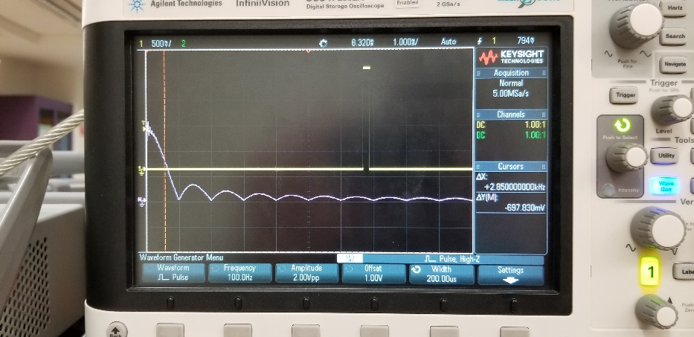

**Fig B.1.2 Spectrum for the Rectangular wave at T=200µs**

**Table B.1.1 Experimental and Theoretical values at 50µs**

|  |  |  |
| --- | --- | --- |
| **Null** | **Experiment** | **Theoretical** |
| 1 | 20 | 20 |
| 2 | 40 | 40 |
| 3 | 60 | 60 |
| 4 | 80 | 80 |

**Table B.1.2 Experimental and Theoretical values at 100µs**

|  |  |  |
| --- | --- | --- |
| **Null** | **Experiment** | **Theoretical** |
| 1 | 9.89 | 10 |
| 2 | 20 | 20 |
| 3 | 30 | 30 |
| 4 | 40 | 40 |

**Table B.1.3 Experimental and Theoretical values at 200µs**

|  |  |  |
| --- | --- | --- |
| **Null** | **Experiment** | **Theoretical** |
| 1 | 4.87 | 5 |
| 2 | 9.8 | 10 |
| 3 | 14.5 | 15 |
| 4 | 20.3 | 20 |

The values recorded in the prelab were identical to the values recorded during the experiment. The gap between the spectral nulls are proportionate to the pulse width

**B.2**

The first zero in the envelope occurs at w = 2π/tau. The tau is a symbolic representation of the pulse width. The magnitude of the spectrum is inversely proportional to the width of the individual pulses. Therefore, a pulse with a narrow width results in a wide range magnitude spectrum.

**C.1**

The input to the linear system sinusoidal graph is similar to the output of the system. The graph indicates that the linear system has lesser distortion whereas in a non-linear system, the output results in higher frequency components during each frequency value. Also the graph pertaining to the non-linear system has more distortion.

**C.2**

System A and B are non-linear and linear systems respectively. A has an input of an isolated frequency and the output is a set of multiple integer values for each frequency value. Therefore, the system does not qualify for linear system properties.

B has the output same as its input. Hence, when the superposition is applied, it is noted that the principle is applicable and the system is linear. The results pertaining to the prelab question 3 indicates that the inputs for the system is a set of sinusoidal waves being shifted at phase produce an output that looks like a cosine function. Since non-linear systems create harmonics, therefore, the sinusoids produced are a result of shifting on the given scale.